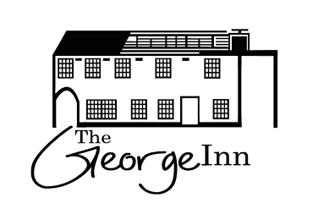
CHRISTMAS FESTIVE MENU

STARTER

Celeriac & apple soup with bread roll.
Ham hock terrine with dried fruits and black pudding on toasted sour dough
Cheddar & stilton cheese balls & pear jelly.
Asian spiced crab samosa with yogurt dip

MAINS

Roast turkey
Served with roast potatoes, roast carrots, sprouts tossed with bacon, seasonal vegetables, yorkshire pudding, stuffing and pigs in blankets.

Fish pie with a whole boiled egg with a cheese herb topping, seasonal vegetables and mash potatoes.
Butternut squash & goats cheese pie with mash potato, greens & gravy
Slow roasted lamb ragu in oregano tomato sauce with tagliatelle

DESSERTS

Xmas pudding with homemade custard.
White chocolate & raspberry bread and butter pudding.
Winter pavlova with caramelized walnuts & apricots
3 cheese board (cheddar, stilton, brie)
MAIN COURSE £17.50
2 COURSE £25.00
3 COURSE £32.50

